Experiment-1
- Create a simple cloud software application and provide it as a service using any Cloud Service Provider to demonstrate Software as a Service (SaaS).
RESULT:
A tiny SaaS demo can be a simple Flask app deployed on Heroku that shows “Hello World” in the browser.
Users access it via a public URL, proving cloud-hosted software delivered as a service.
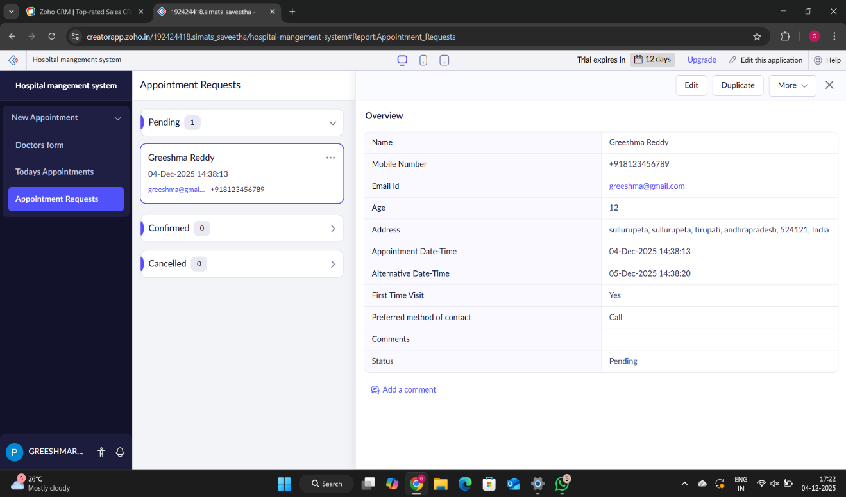

EXPERIMENT-2
- Create a simple cloud software application for Flight Reservation System using any Cloud Service Provider to demonstrate SaaS.
RESULT:
The Flight Reservation SaaS app is deployed on the cloud and accessible via a public URL.
Users can view flights, reserve seats online, and use the service directly through their browser.
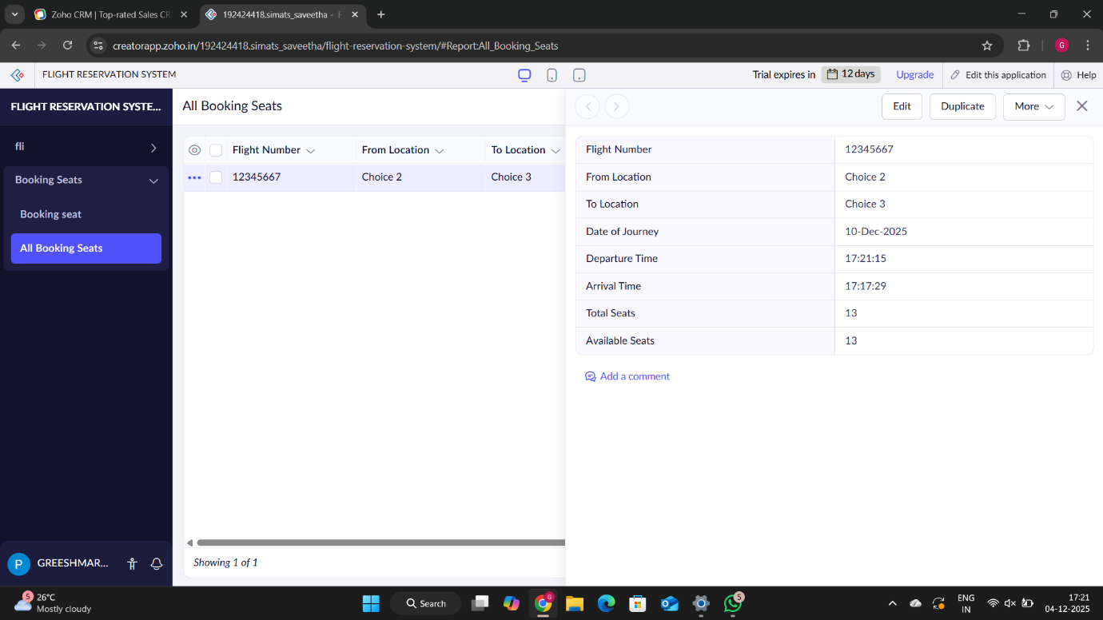

EXPERIMENT-3
- Create a simple cloud software application for Property Buying & Rental process (In Chennai city) using any Cloud Service Provider to demonstrate SaaS.
RESULT:
The Property Buying & Rental SaaS app is deployed on the cloud and accessible via a public URL.
Users in Chennai can browse listings, book rentals, or initiate property purchases directly through their browser.
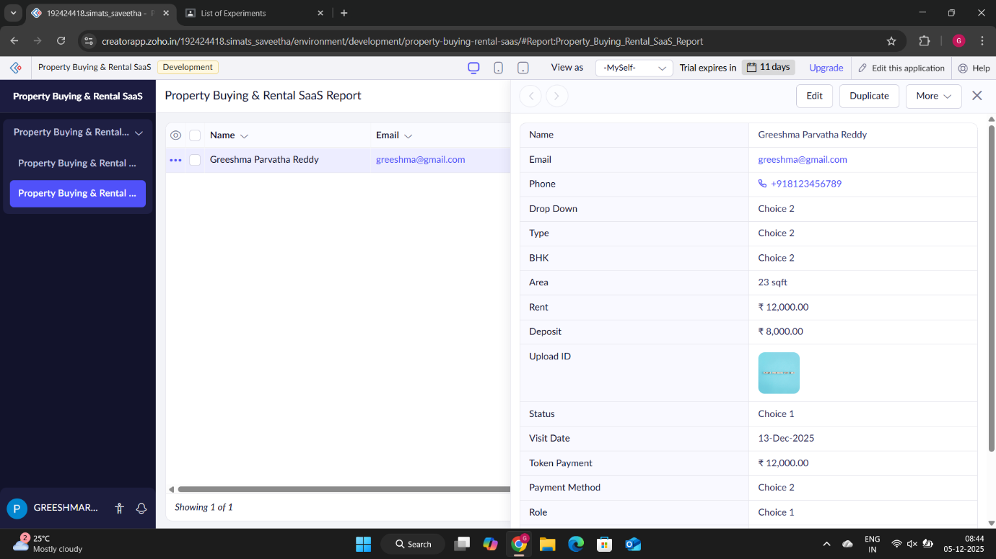

EXPERIMENT-4
- Create a simple cloud software application for Car Booking Reservation System using any Cloud Service Provider to demonstrate SaaS.
RESULT:
The Car Booking Reservation SaaS app is deployed on the cloud and accessible via a public URL.
Users can browse available cars, reserve bookings online, and access the service directly through their browser.
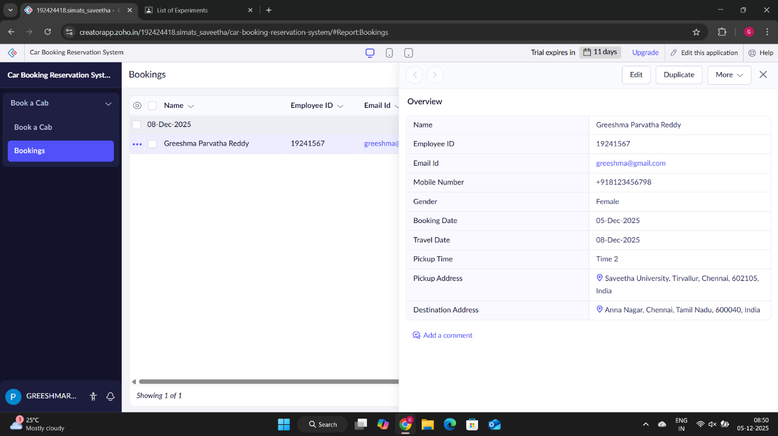

EXPERIMENT-5
- Create a simple cloud software application for Library book reservation system for SIMATS library using any Cloud Service Provider to demonstrate SaaS.
RESULT:
The Library Book Reservation SaaS app is deployed on the cloud and accessible via a public URL.
Students of SIMATS can browse available books and reserve them online directly through their browser.
